Ecperiments-11-21
11. Read a CSV file and display its contents
R-Code:
data <- read.csv("C:/Users/yaswa/OneDrive/文档/exam_data.csv")
print("Contents of the CSV file:")
print(data)

Output:
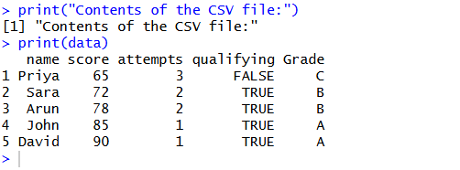

12. Data reshaping and monthly averages using airquality

R-Code:
data("airquality")
result <- aggregate(
cbind(Ozone, Solar.R, Wind, Temp) ~ Month,
data = airquality,
FUN = mean,
na.rm = TRUE
)
print("Monthly average values:")
print(result)

Output:
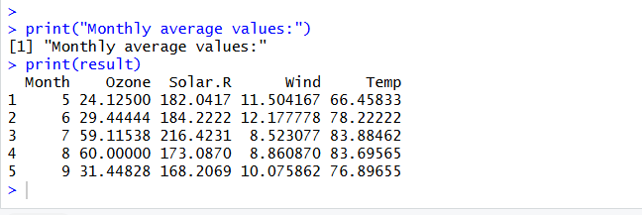

13. Combine multiple arrays row-wise
R-Code:
a <- c(1, 2, 3)
b <- c(4, 5, 6)
c <- c(7, 8, 9)
d <- rbind(a, b, c)
print("Combined arrays (row-wise):")
print(d)

Output:
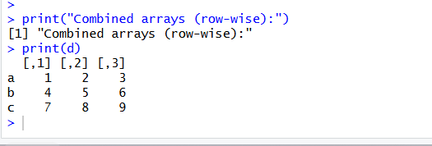

14. Explore and manipulate the ChickWeight dataset
R-Code:
data("ChickWeight")
print("First few rows:")
print(head(ChickWeight))

sorted <- ChickWeight[order(ChickWeight$weight), ]
print("Sorted by weight:")
print(sorted)
print("Average weight by Diet:")
print(aggregate(weight ~ Diet, data = ChickWeight, FUN = mean))
Output:
> data("ChickWeight")
>
> print("First few rows:")
[1] "First few rows:"
> print(head(ChickWeight))
weight Time Chick Diet
1 42 0 1 1
2 51 2 1 1
3 59 4 1 1
4 64 6 1 1
5 76 8 1 1
6 93 10 1 1
>
> sorted <- ChickWeight[order(ChickWeight$weight), ]
>
> print("Sorted by weight:")
[1] "Sorted by weight:"
> print(sorted)
weight Time Chick Diet
196 35 2 18 1
26 39 2 3 1
195 39 0 18 1
293 39 0 27 2
305 39 0 28 2
317 39 0 29 2
365 39 0 33 3
401 39 0 36 3
543 39 0 48 4
13 40 0 2 1
221 40 0 21 2
269 40 0 25 2
519 40 0 46 4
555 40 0 49 4
49 41 0 5 1
61 41 0 6 1
73 41 0 7 1
108 41 0 10 1
132 41 0 12 1
144 41 0 13 1
156 41 0 14 1
168 41 0 15 1
176 41 0 16 1
209 41 0 20 1
233 41 0 22 2
353 41 0 32 3
377 41 0 34 3
389 41 0 35 3
413 41 0 37 3
425 41 0 38 3
449 41 0 40 3
507 41 0 45 4
531 41 0 47 4
567 41 0 50 4
1 42 0 1 1
37 42 0 4 1
50 42 2 5 1
85 42 0 8 1
96 42 0 9 1
183 42 0 17 1
257 42 0 24 2
281 42 0 26 2
329 42 0 30 2
341 42 0 31 3
437 42 0 39 3
461 42 0 41 4
473 42 0 42 4
485 42 0 43 4
497 42 0 44 4
25 43 0 3 1
120 43 0 11 1
197 43 0 19 1
245 43 0 23 2
109 44 2 10 1
177 45 2 16 1
294 46 2 27 2
306 46 2 28 2
210 47 2 20 1
51 48 4 5 1
145 48 2 13 1
198 48 2 19 1
282 48 2 26 2
318 48 2 29 2
330 48 2 30 2
402 48 2 36 3
414 48 2 37 3
14 49 2 2 1
38 49 2 4 1
62 49 2 6 1
74 49 2 7 1
133 49 2 12 1
157 49 2 14 1
169 49 2 15 1
178 49 4 16 1
270 49 2 25 2
354 49 2 32 3
378 49 2 34 3
426 49 2 38 3
474 49 2 42 4
86 50 2 8 1
222 50 2 21 2
366 50 2 33 3
438 50 2 39 3
508 50 2 45 4
544 50 2 48 4
2 51 2 1 1
97 51 2 9 1
121 51 2 11 1
179 51 6 16 1
181 51 10 16 1
184 51 2 17 1
462 51 2 41 4
498 51 2 44 4
110 52 4 10 1
246 52 2 23 2
258 52 2 24 2
520 52 2 46 4
146 53 4 13 1
342 53 2 31 3
390 53 2 35 3
532 53 2 47 4
556 53 2 49 4
182 54 12 16 1
211 54 4 20 1
568 54 2 50 4
27 55 4 3 1
199 55 4 19 1
234 55 2 22 2
450 55 2 40 3
486 55 2 43 4
39 56 4 4 1
134 56 4 12 1
170 56 4 15 1
415 56 4 37 3
75 57 4 7 1
180 57 8 16 1
283 57 4 26 2
15 58 4 2 1
212 58 6 20 1
259 58 4 24 2
295 58 4 27 2
307 58 4 28 2
3 59 4 1 1
63 59 4 6 1
98 59 4 9 1
319 59 4 29 2
331 59 4 30 2
52 60 6 5 1
147 60 6 13 1
87 61 4 8 1
185 61 4 17 1
247 61 4 23 2
403 61 4 36 3
427 61 4 38 3
439 61 4 39 3
509 61 4 45 4
135 62 6 12 1
158 62 4 14 1
200 62 6 19 1
223 62 4 21 2
271 62 4 25 2
343 62 4 31 3
521 62 4 46 4
545 62 4 48 4
111 63 6 10 1
122 63 4 11 1
367 63 4 33 3
379 63 4 34 3
475 63 4 42 4
4 64 6 1 1
171 64 6 15 1
235 64 4 22 2
391 64 4 35 3
557 64 4 49 4
148 65 8 13 1
201 65 8 19 1
213 65 8 20 1
355 65 4 32 3
499 65 4 44 4
261 66 8 24 2
451 66 4 40 3
463 66 4 41 4
533 66 4 47 4
28 67 6 3 1
40 67 6 4 1
149 67 10 13 1
174 67 12 15 1
569 67 4 50 4
99 68 6 9 1
172 68 8 15 1
173 68 10 15 1
175 68 14 15 1
262 68 10 24 2
416 68 6 37 3
487 69 4 43 4
151 70 14 13 1
263 70 12 24 2
76 71 6 7 1
88 71 6 8 1
150 71 12 13 1
152 71 16 13 1
202 71 10 19 1
264 71 14 24 2
16 72 6 2 1
136 72 8 12 1
186 72 6 17 1
265 72 16 24 2
266 72 18 24 2
332 72 6 30 2
214 73 10 20 1
248 73 6 23 2
296 73 6 27 2
308 73 6 28 2
344 73 6 31 3
41 74 8 4 1
64 74 6 6 1
112 74 8 10 1
260 74 6 24 2
268 74 21 24 2
284 74 6 26 2
320 74 6 29 2
428 74 6 38 3
5 76 8 1 1
267 76 20 24 2
404 76 6 36 3
215 77 12 20 1
236 77 6 22 2
368 77 6 33 3
272 78 6 25 2
440 78 6 39 3
510 78 6 45 4
53 79 8 5 1
159 79 6 14 1
452 79 6 40 3
534 79 6 47 4
417 80 8 37 3
546 80 6 48 4
113 81 10 10 1
153 81 18 13 1
203 82 12 19 1
356 82 6 32 3
522 82 6 46 4
187 83 8 17 1
418 83 10 37 3
17 84 8 2 1
29 84 8 3 1
89 84 8 8 1
123 84 6 11 1
476 84 6 42 4
570 84 6 50 4
100 85 8 9 1
333 85 8 30 2
345 85 8 31 3
380 85 6 34 3
464 85 6 41 4
558 85 6 49 4
224 86 6 21 2
500 86 6 44 4
42 87 10 4 1
297 87 8 27 2
321 87 8 29 2
392 87 6 35 3
137 88 10 12 1
204 88 14 19 1
77 89 8 7 1
114 89 12 10 1
188 89 10 17 1
216 89 14 20 1
441 89 8 39 3
102 90 12 9 1
[ reached 'max' / getOption("max.print") -- omitted 328 rows ]
>
> print("Average weight by Diet:")
[1] "Average weight by Diet:"
> print(aggregate(weight ~ Diet, data = ChickWeight, FUN = mean))
Diet weight
1 1 102.6455
2 2 122.6167
3 3 142.9500
4 4 135.2627

Q15. Exploratory data analysis (EDA) on iris
R-Code:
data("iris")
print("Dimensions:")
print(dim(iris))
print("Summary:")
print(summary(iris))
print("Standard deviation:")
print(sapply(iris[, 1:4], sd))

print("Sepal Length quantiles:")
print(quantile(iris$Sepal.Length))
print("Mean values by Species:")
print(aggregate(. ~ Species, data = iris, FUN = mean))
print("Pivot table:")
print(xtabs(~ Species, data = iris))
iris$Sepal_Category <- cut(
iris$Sepal.Length,
breaks = c(0, 5, 6, Inf),
labels = c("Short", "Medium", "Long")
)
print("Species counts by Sepal Length category:")
print(table(iris$Species, iris$Sepal_Category))

Output:
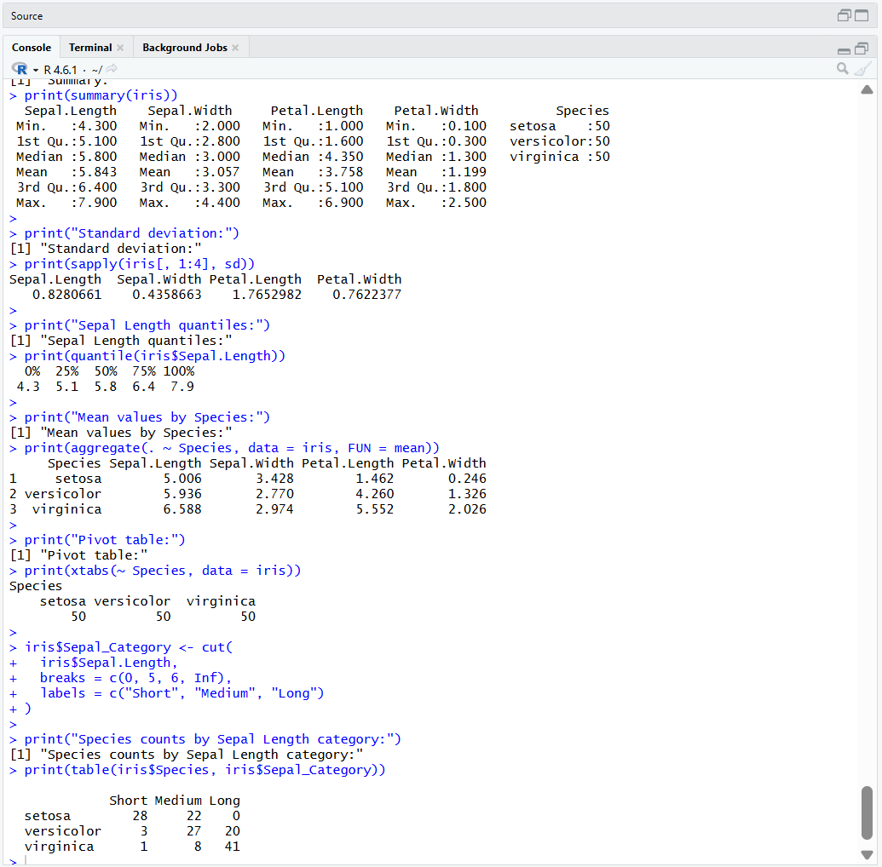

Q17. Explore the Titanic dataset
R-Code:
data("Titanic")
t <- as.data.frame(Titanic)
print("Titanic dataset:")
print(head(t))
print("Survival vs Class:")
barplot(
table(t$Class, t$Survived),
main = "Survival vs Class",
xlab = "Class",
ylab = "Frequency",
beside = TRUE,
col = c("lightblue", "lightgreen"),
legend = TRUE
)
print("Survival vs Gender:")
barplot(
table(t$Sex, t$Survived),
main = "Survival vs Gender",
xlab = "Gender",
ylab = "Frequency",
beside = TRUE,
col = c("lightblue", "lightgreen"),
legend = TRUE
)
print("Age category frequencies:")
print(table(t$Age))
barplot(
table(t$Age),
main = "Titanic Age Categories",
xlab = "Age Category",
ylab = "Frequency",
col = "orange"
)
Output:
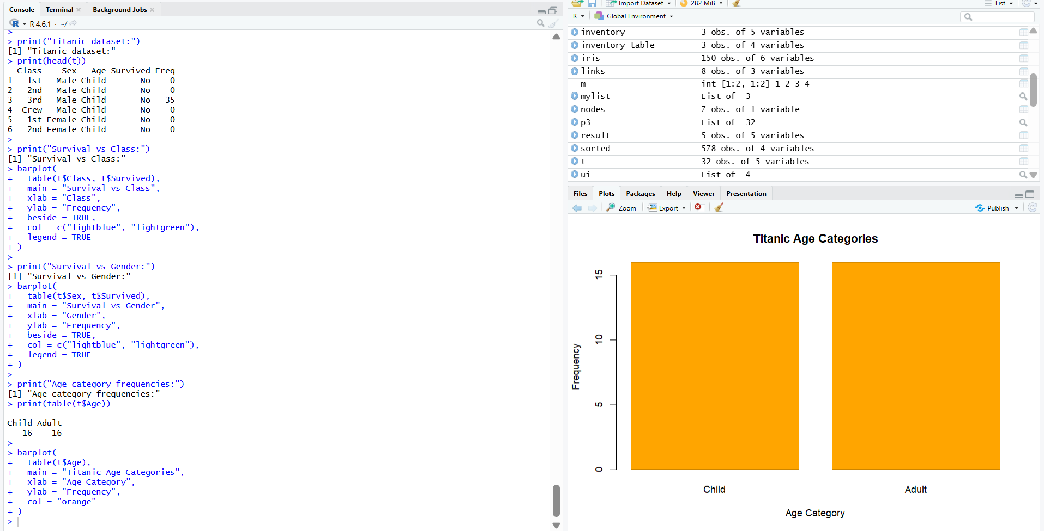

Q18. Create graphs in R

R-code:
x <- c(10, 20, 30, 40, 50)
y <- c(5, 15, 25, 35, 45)
par(mfrow = c(2, 3))
boxplot(x, main = "Boxplot", col = "lightblue")
hist(x, main = "Histogram", col = "lightgreen")
barplot(
x,
main = "Bar Plot",
col = "orange",
names.arg = c("A", "B", "C", "D", "E")
)

plot(x, type = "l", main = "Line Chart",
xlab = "Index", ylab = "Value", col = "blue")
plot(x, y, main = "Scatter Plot",
xlab = "X", ylab = "Y", col = "red", pch = 19)
plot.new()

Output:
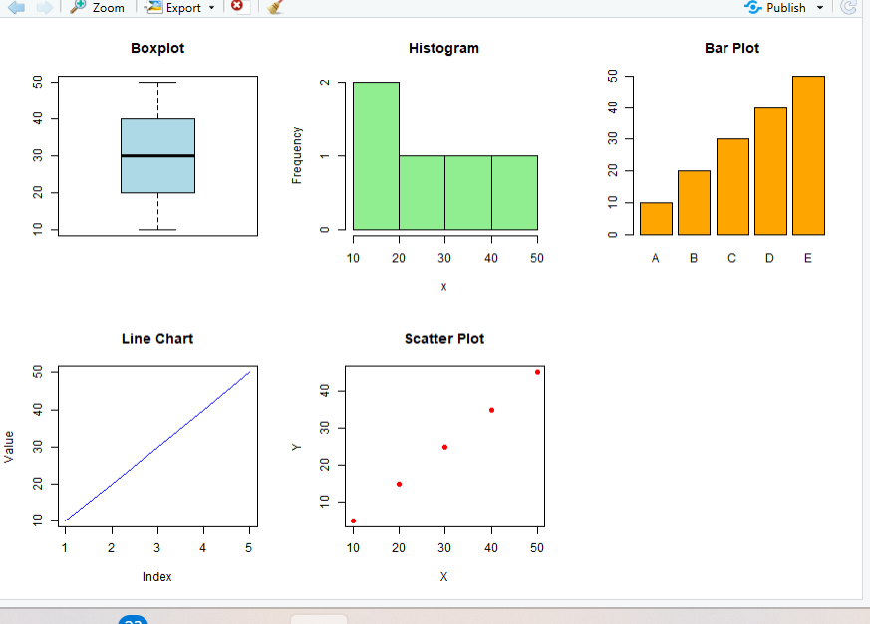

19. Build a regression model on an advertising dataset
R-Code:
Spend <- c(10, 20, 30, 40, 50)
Sales <- c(15, 25, 35, 45, 55)

data <- data.frame(Spend, Sales)
model <- lm(Sales ~ Spend, data = data)
print("Regression model:")
print(summary(model))
new_data <- data.frame(Spend = 60)
prediction <- predict(model, newdata = new_data)
print("Predicted Sales:")
print(prediction)
plot(Spend, Sales,
main = "Advertising Spend vs Sales",
xlab = "Spend", ylab = "Sales",
pch = 19, col = "blue")
abline(model, col = "red", lwd = 2)

Output:
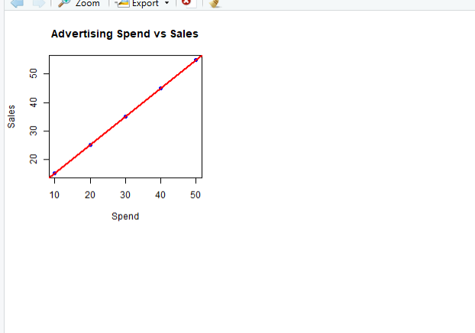

20. Multiple regression using ChickWeight
R-Code:
data("ChickWeight")
model <- lm(weight ~ Time + Diet, data = ChickWeight)
print("Regression model:")
print(summary(model))
predicted <- predict(model)

print("Predicted weights:")
print(head(predicted))
mse <- mean((ChickWeight$weight - predicted)^2)
print("Mean Squared Error:")
print(mse)
new_data <- data.frame(
Time = c(10, 20),
Diet = factor(c(1, 2), levels = levels(ChickWeight$Diet))
)
print("Predicted weight for new data:")
print(predict(model, newdata = new_data))

Output:
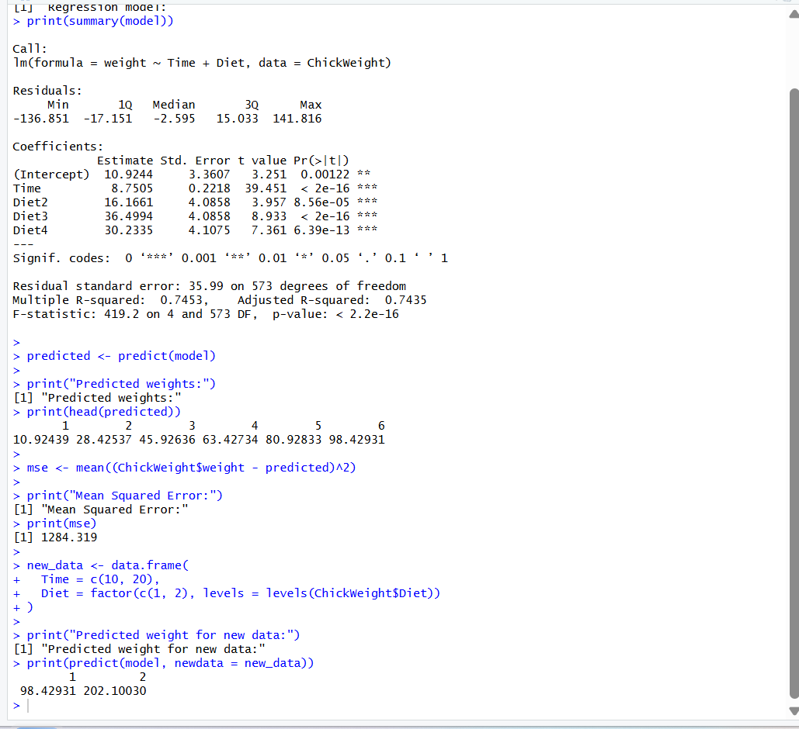

21. Randomly split the iris dataset into train/test (80/20), build logistic regression, predict, and evaluate with a confusion matrix.

R-Code:
data("iris")
set.seed(123)
# Select two species
iris_data <- subset(
iris,
Species %in% c("setosa", "versicolor")
)
# Split data into 80% training and 20% testing
train_index <- sample(
1:nrow(iris_data),
size = 0.8 * nrow(iris_data)
)
train_data <- iris_data[train_index, ]
test_data <- iris_data[-train_index, ]
# Build logistic regression model
model <- glm(
Species ~ Petal.Length + Petal.Width,
data = train_data,
family = binomial
)
# Predict probabilities
probabilities <- predict(
model,
newdata = test_data,
type = "response"
)
# Convert probabilities into species predictions
predictions <- ifelse(
probabilities > 0.5,
"versicolor",
"setosa"
)

# Display confusion matrix
print("Confusion Matrix:")
print(table(
Predicted = predictions,
Actual = test_data$Species
))
# Calculate accuracy
accuracy <- mean(
predictions == as.character(test_data$Species)
) * 100
print("Accuracy:")
print(paste(round(accuracy, 2), "%"))

Output:
